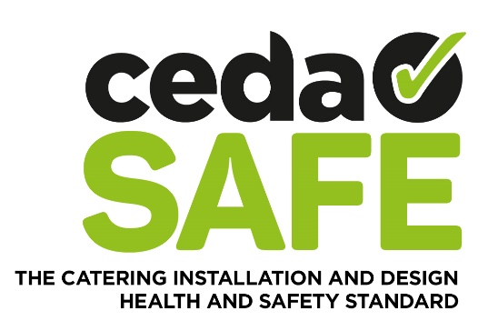

ceda SAFE is a health and safety accreditation available to any company working in the sector that achieve the necessary Health & Safety levels and covers both Design and Installation.

It has been devised as a result of discussion with the Health & Safety Executive who have highlighted a need to reduce bureaucracy and the cost of the various pre-qualification assessments, by establishing a single assessment standard for our Industry.

It is the most efficient accreditation to attain in terms of the paperwork required and it is the most cost-effective scheme to achieve. Yet, crucially, it achieves the same level of core criteria as all of the other schemes that are in the marketplace at the moment.

It requires the absolute necessary information but no more, so it is in no way diluted in order to make its’ attainment easy or cheap.

- If you are a company that offers Design and Installation services, you can achieve the ceda SAFE accreditation in order to promote your business as operating to the highest levels of independently verified Health & Safety, hitting all of the core criteria as required by the HSE

- If you sub-contract elements of the project installation, you can assess your sub-contractors by insisting that they have ceda SAFE accreditation.

- If you are a supplier or manufacturer of equipment that use sub-contractors for installation and maintenance, you can assess those sub-contractors by insisting they have ceda SAFE accreditation. So, there is no need to create your own assessment documents to send out to your entire supply-chain to then verify and administer.

- If you are a sub-contractor company then you should not need to complete form after form for company after company that you want to work with.

If you already hold any of the following certifications – CHAS, Exor, SMAS, NHBC Safemark, Altius, Eurosafe, APS, Alcumus, Safe-T-Cert, MSL Safepartner, Greenlight, CQMS, HSAS, Acclaim, Avetta, ARB, FASET, PASS, PQS, NASC, IPAF, Achilles or ACDC - then you are required to complete a form giving your company details and submit along with your valid certificate and supporting documents and pay a fee of £120 plus VAT annually.

If you do not already hold any of these certifications then you are required to complete a 28 page document and submit along with the necessary supporting documentation, pay a fee of £250 plus VAT in the first year and then £150 annually thereafter.

